<https://i.stack.imgur.com/7sFL3.png>

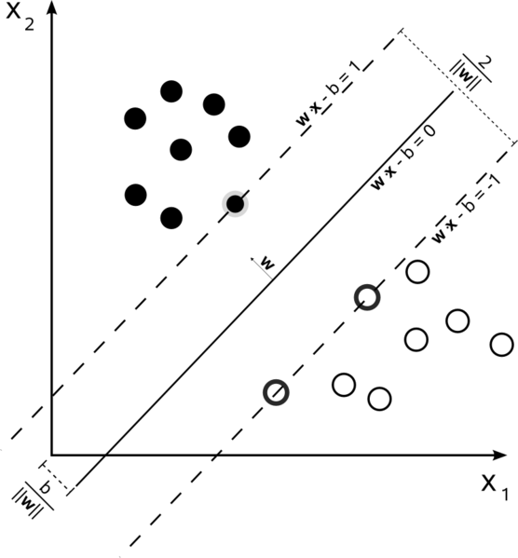

<https://www.frontiersin.org/files/Articles/214674/fpsyg-08-00156-HTML/image_m/fpsyg-08-00156-g003.jpg>

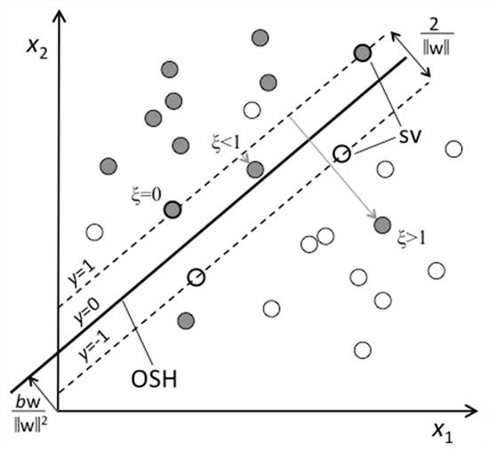

<http://yaroslavvb.com/upload/save/so-libsvm.png>

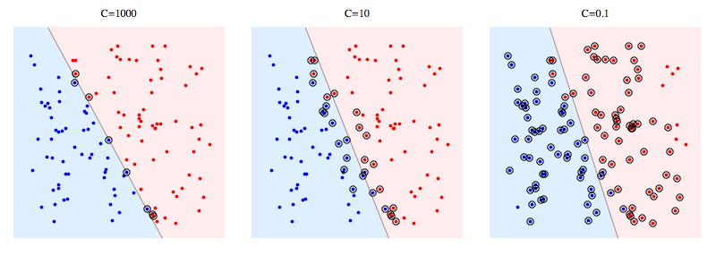

<https://i.stack.imgur.com/npEOk.png>

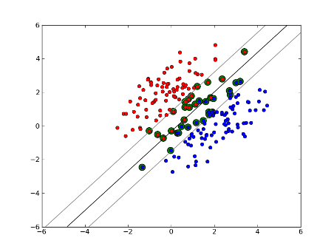

<https://www.researchgate.net/profile/Marimuthu_Palaniswami/publication/220606206/figure/download/fig2/AS:339477512900611@1457949154899/The-soft-margin-SVM-classifier-with-slack-variables-x-and-support-vectors-shown.png>

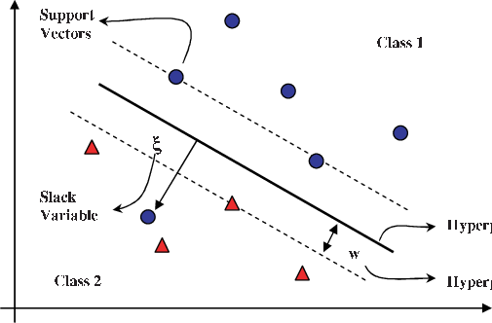

<http://www.coxdocs.org/lib/exe/fetch.php?media=perseus:user:activities:matrixprocessing:learning:svm.png>

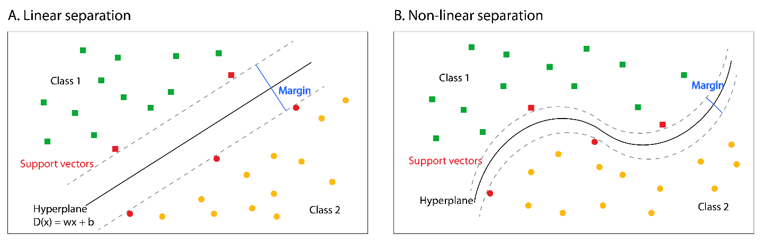

<https://i.ytimg.com/vi/_21sRvMNgPo/maxresdefault.jpg>

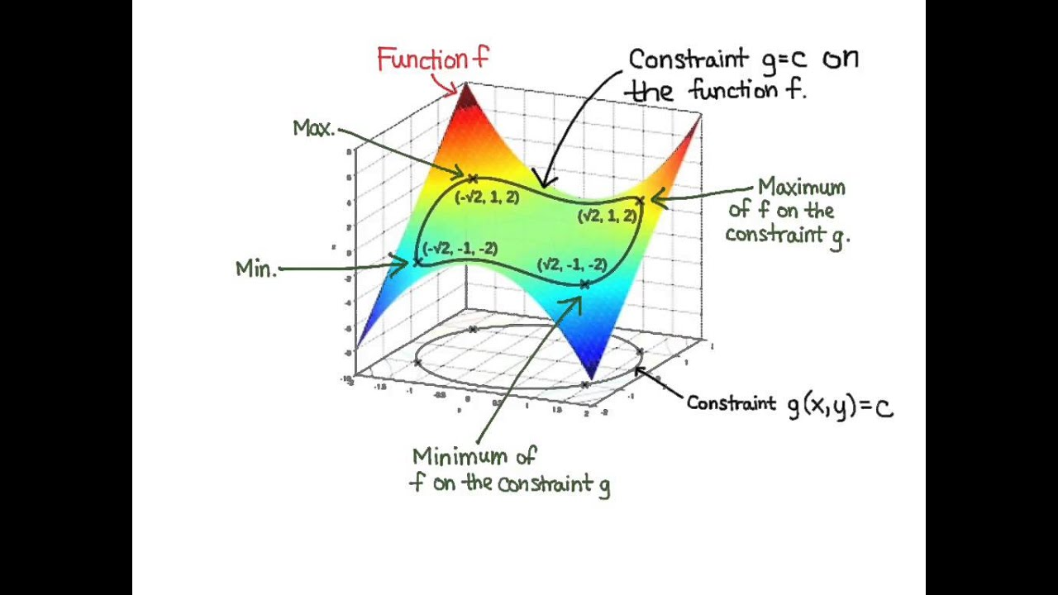

<https://jcrisch.files.wordpress.com/2015/04/descente-gradient-3d.jpg>

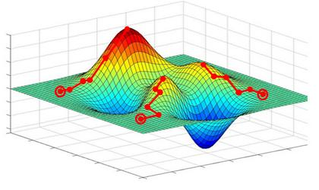

<https://image.slidesharecdn.com/14-svmclassification-171230051757/95/svm-classification-9-638.jpg?cb=1514611401>

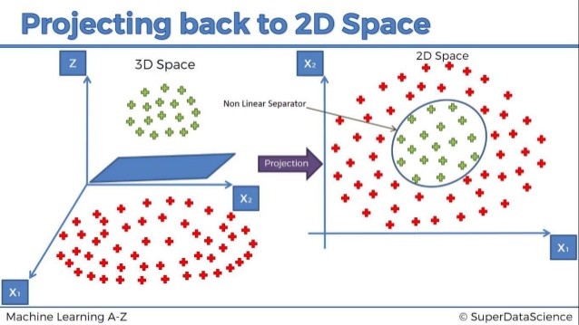

<https://blog-c7ff.kxcdn.com/blog/wp-content/uploads/2017/02/kernel.png>

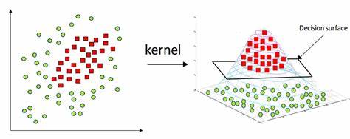

<https://upload.wikimedia.org/wikipedia/commons/d/d8/Kernel_yontemi_ile_veriyi_daha_fazla_dimensiyonlu_uzaya_tasima_islemi.png>

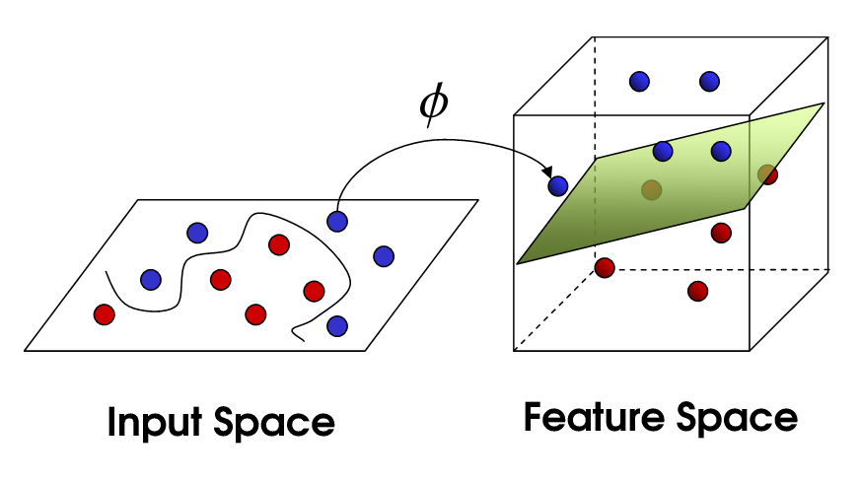

<https://bogotobogo.com/python/scikit-learn/images/svm2/kernel-method-nonlinear-svm.png>

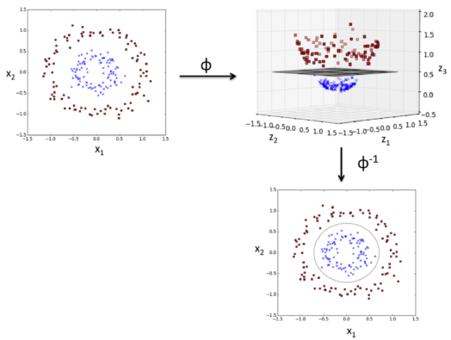

[https://miro.medium.com/max/1312/0*-_oXIrD3FQUA4YpW](https://miro.medium.com/max/1312/0*-_oXIrD3FQUA4YpW).

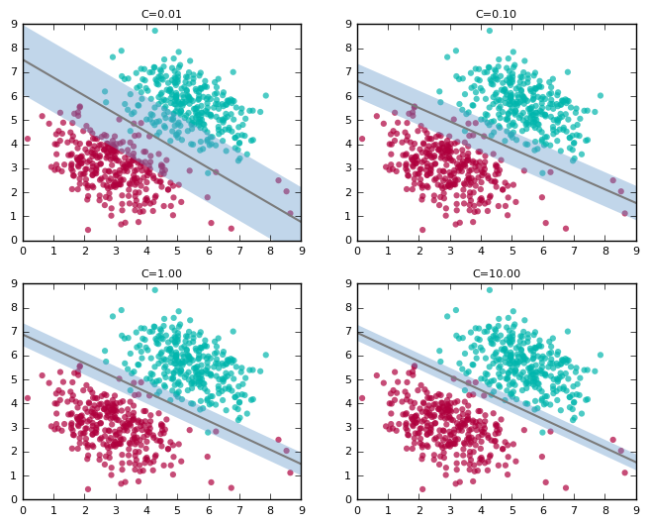

<https://yifeitao.com/assets/images/loss.png>

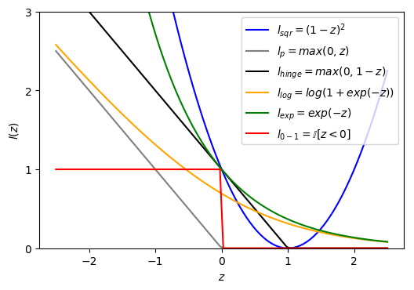

<https://i.imgur.com/QkQ5kNw.jpg>

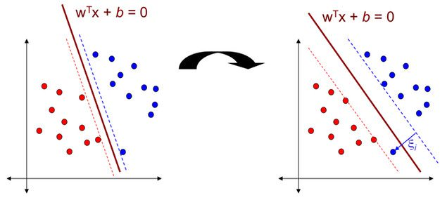

<https://www.bogotobogo.com/python/scikit-learn/images/svm/SVM-Hyperplane-Maximizing-Margin.png>

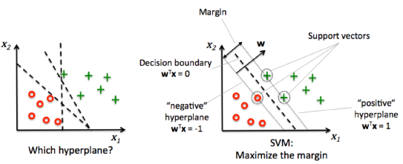

<https://i1.wp.com/ivyproschool.com/blog/wp-content/uploads/2015/08/Diagram2_SVM.png?resize=619%2C227>

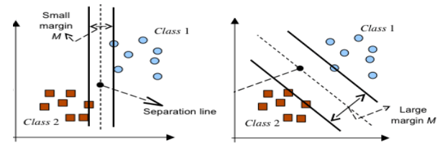

<https://image.slidesharecdn.com/2-150507064445-lva1-app6891/95/26-support-vector-machines-and-associative-classifiers-revised-5-638.jpg?cb=1430981379>

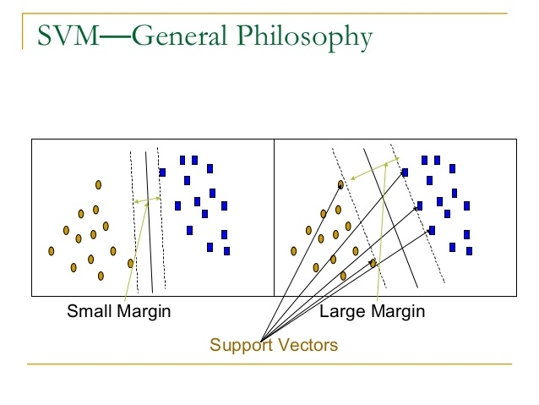

<http://python.astrotech.io/_images/svm-hyperplane-polynomial.png>

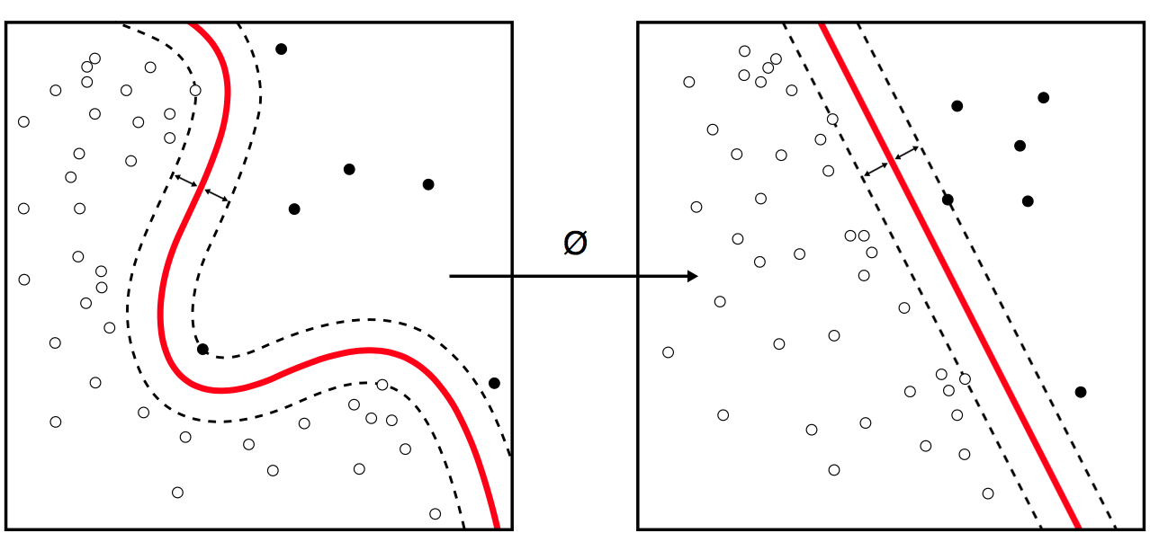

<https://machinelearningwithmlr.files.wordpress.com/2019/10/ch06_fig_6_mlr.png?w=750>

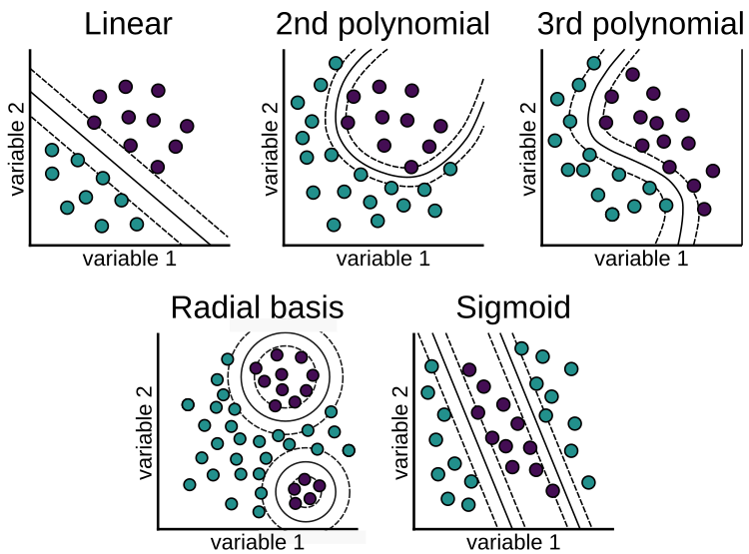

[https://miro.medium.com/max/1400/1*Ha7EfcfB5mY2RIKsXaTRkA.png](https://miro.medium.com/max/1400/1*Ha7EfcfB5mY2RIKsXaTRkA.png)

